## **Two Point**

**Program Description:**

Create a program which graphs two points and then graphs the line formed by those two points. Program finds aspects of the line through calculation.

**Rubric:**

**“B”**

- Y Intercept - Midpoint - Equation - 2 points - Distance - Slope

**“A”**

- user friendliness -able to click points on graph -continuous lines -triangle form - more than 2 points

**Sample output:**

1. Gui before any input/Gui after clear button: 2. Graphing by clicking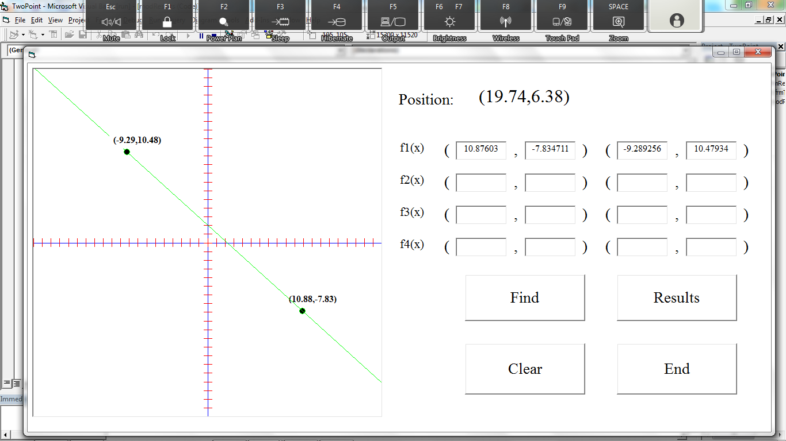

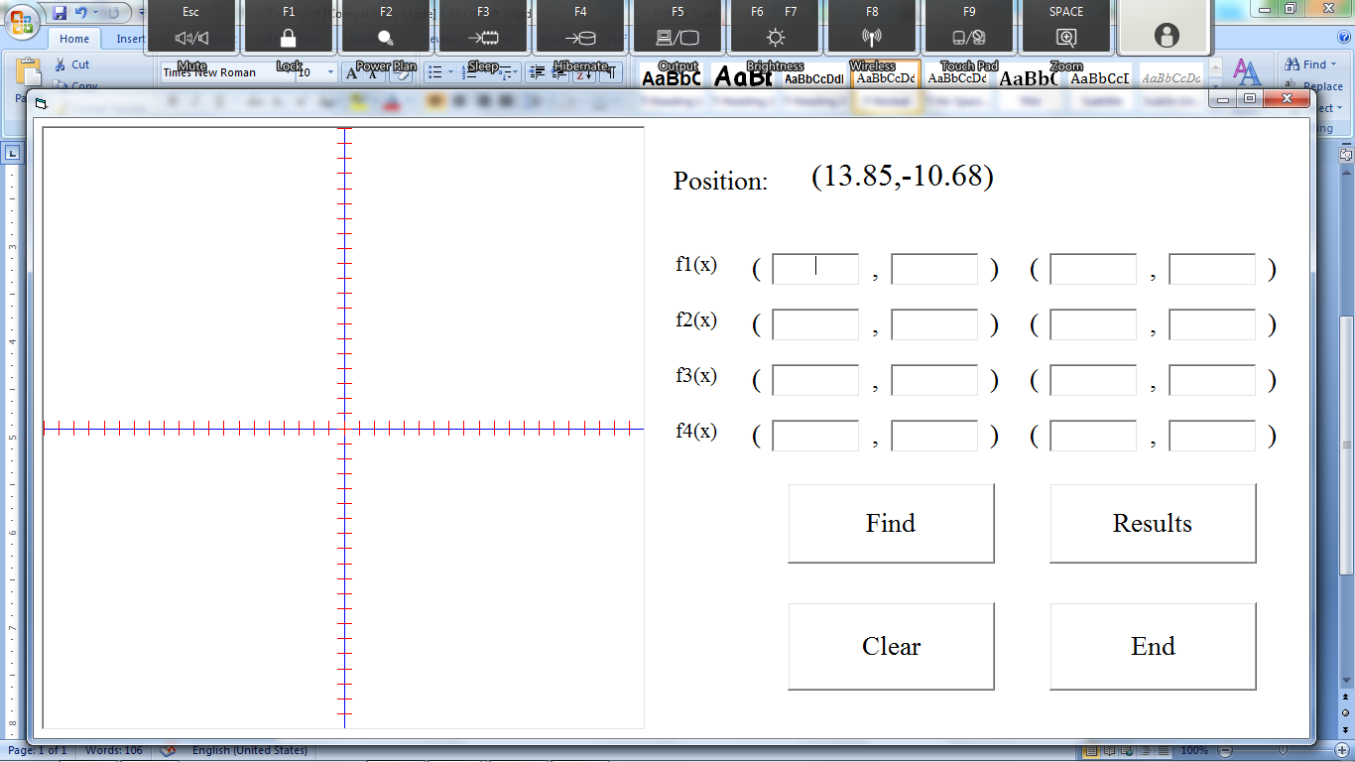

3. Graphing by inputting coordinates* 4. Graphing Two Lines

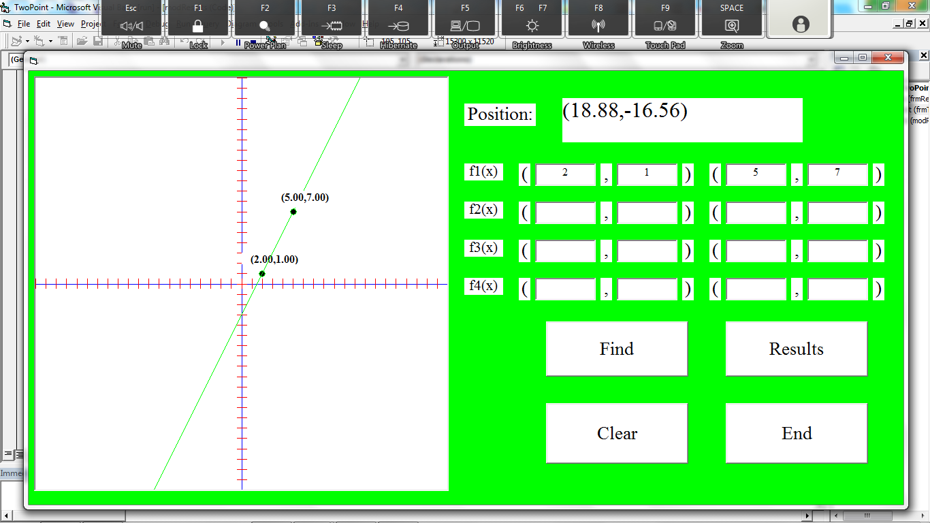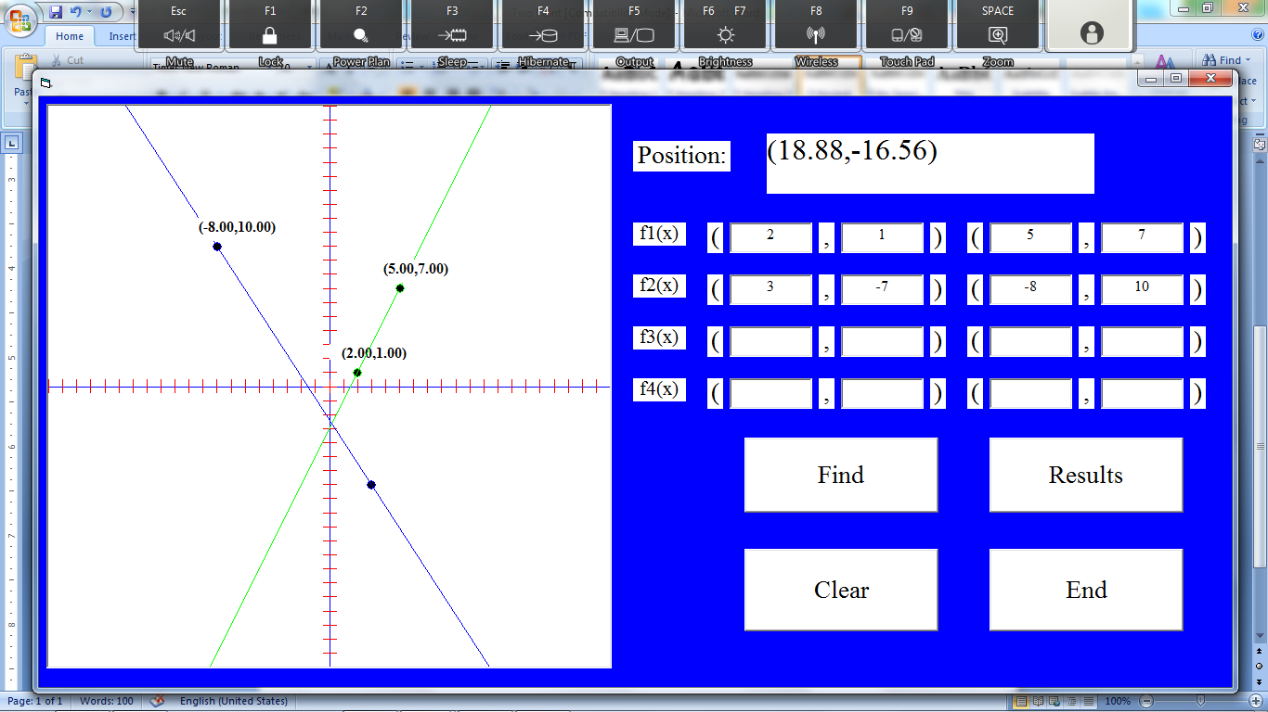

5. More than 2 points ** 6. Showing the Results ***

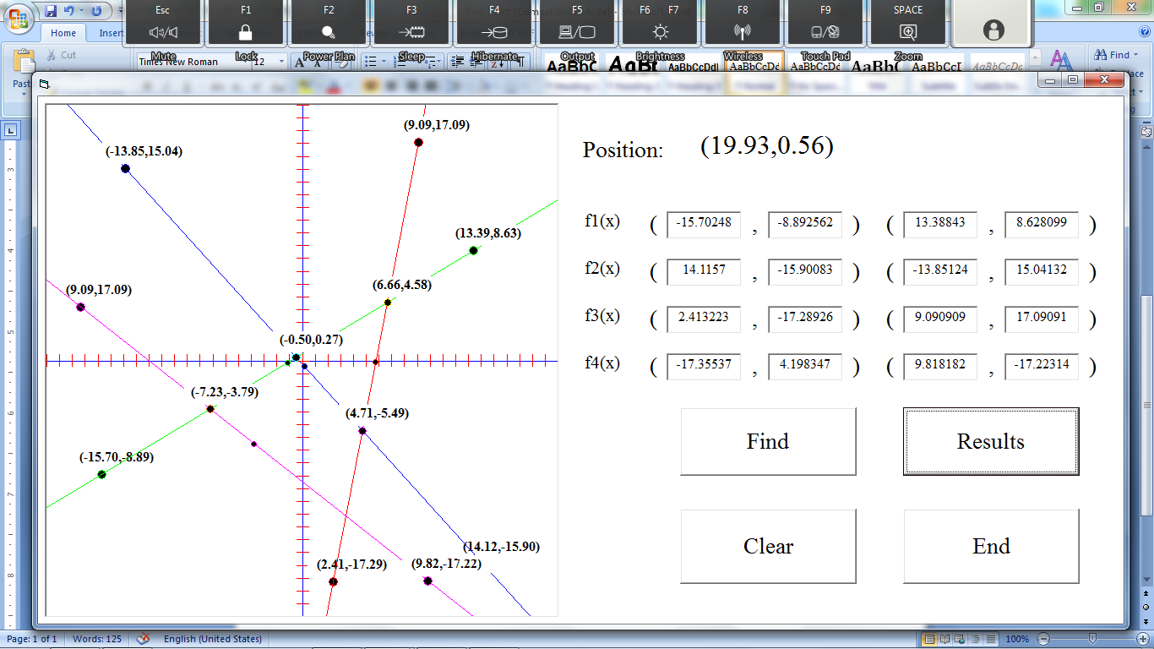 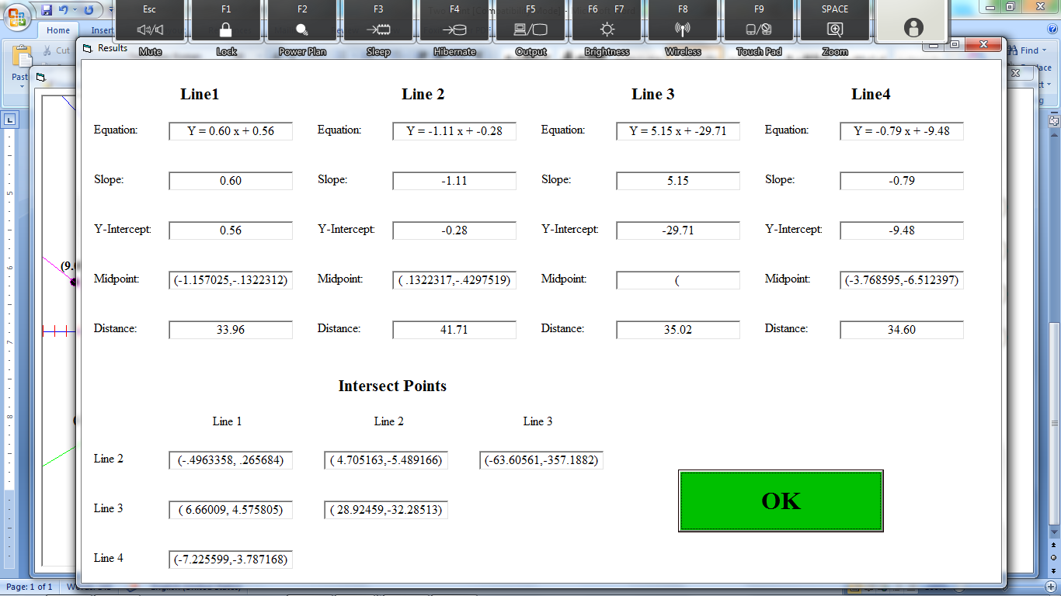

* Program changes color based on line color

**Figure 5 done through graphing by clicking, Find button finds the intersects and shows the points

***Results are shown in different form/not required